April 26 – Bug Docu/Not working functionalities

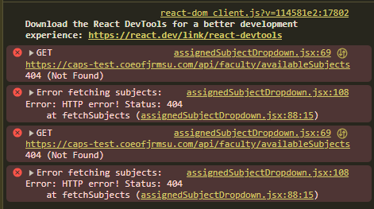
Can’t View and Assign Available Subjects

ERROR TEXT:
assignedSubjectDropdown.jsx:69 GET https://caps-test.coeofjrmsu.com/api/faculty/availableSubjects 404 (Not Found)
assignedSubjectDropdown.jsx:108 Error fetching subjects: Error: HTTP error! Status: 404 at fetchSubjects (assignedSubjectDropdown.jsx:88:15)
assignedSubjectDropdown.jsx:69 GET https://caps-test.coeofjrmsu.com/api/faculty/availableSubjects 404 (Not Found)
assignedSubjectDropdown.jsx:108 Error fetching subjects: Error: HTTP error! Status: 404 at fetchSubjects (assignedSubjectDropdown.jsx:88:15)
﻿
Steps to Replicate the Bug
- Log in as faculty
- Click the Sidebar to Select a Subject
- Add and Assign a Subject for you
User Used

23-A-02087
Kent

